Website Search Engine Optimization Audit For:
ABC Institute
https://www.wetrain.org/
A Service provided by BoardroomPR
Date: August 15, 2023
Search Engine Optimization
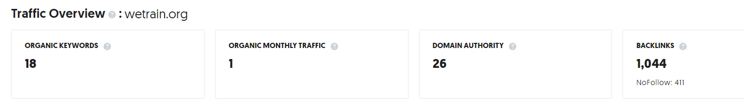
Sister website ABCEastFlorida.com (active SEO program)
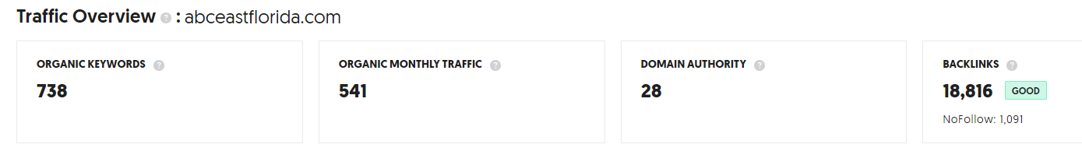

WeTrain.org Website Traffic
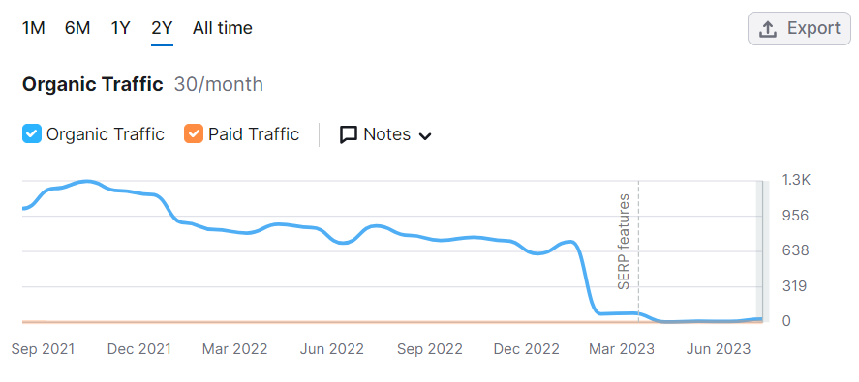

Number of Search Engine Keywords that Wetrain.org ranks in Google Search

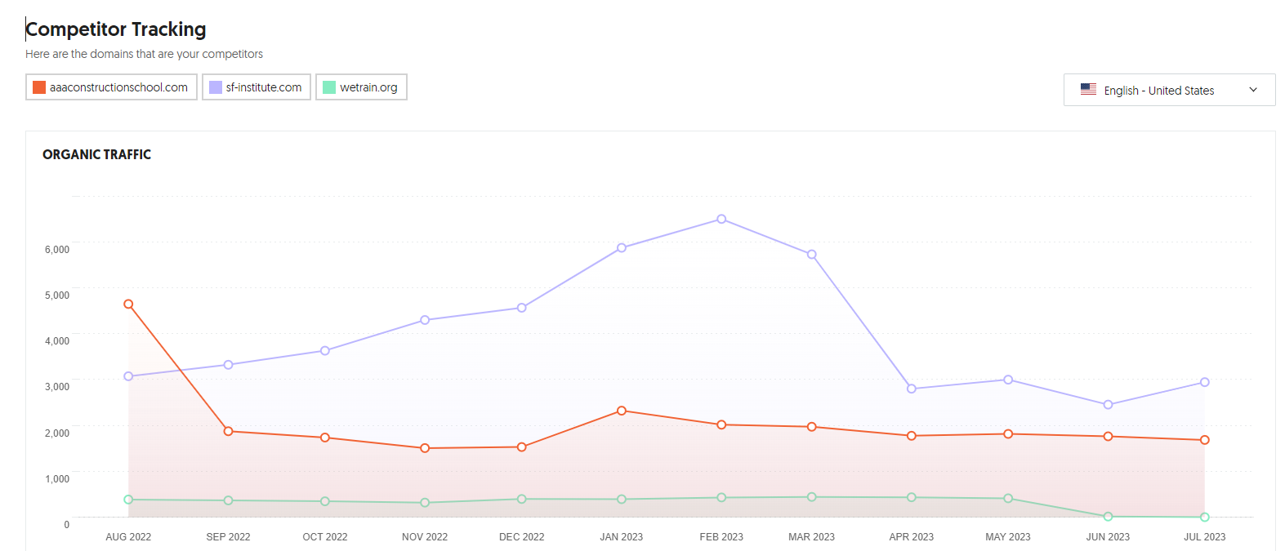
Analysis: SEO Backlinks
The Number of quality backlinks from other websites indicates to the Google algorithm that your website is a trusted authority on the internet. The greater the number of quality keyword anchor text backlinks the higher the search ranking results. It is common for high-ranking websites to have thousands of quality “follow” backlinks.

Wetrain.org backlinks: The number of wetrain.org backlinks has declined from a high of over 5,000 backlinks to 1,044 or a decline of 79%. Furthermore, No Follow backlinks (social media links) have little to no Search Engine Optimization value. The number of “Follow” backlinks is only 633.

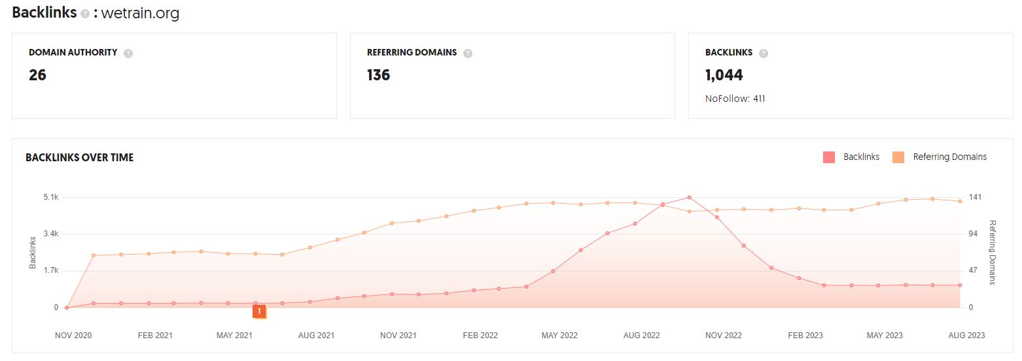
Important: Referring domains should be from quality websites that are located in the United States.
SEO Content Recommendation – Create 7 “City Pages”
There are currently no content pages for each of the 7 locations. It is advisable to create a page of content for each location. Each page requires original content and should provide significant details on all the classes taught at that location. The page content for each “City Page” should be 1,500 words or longer.
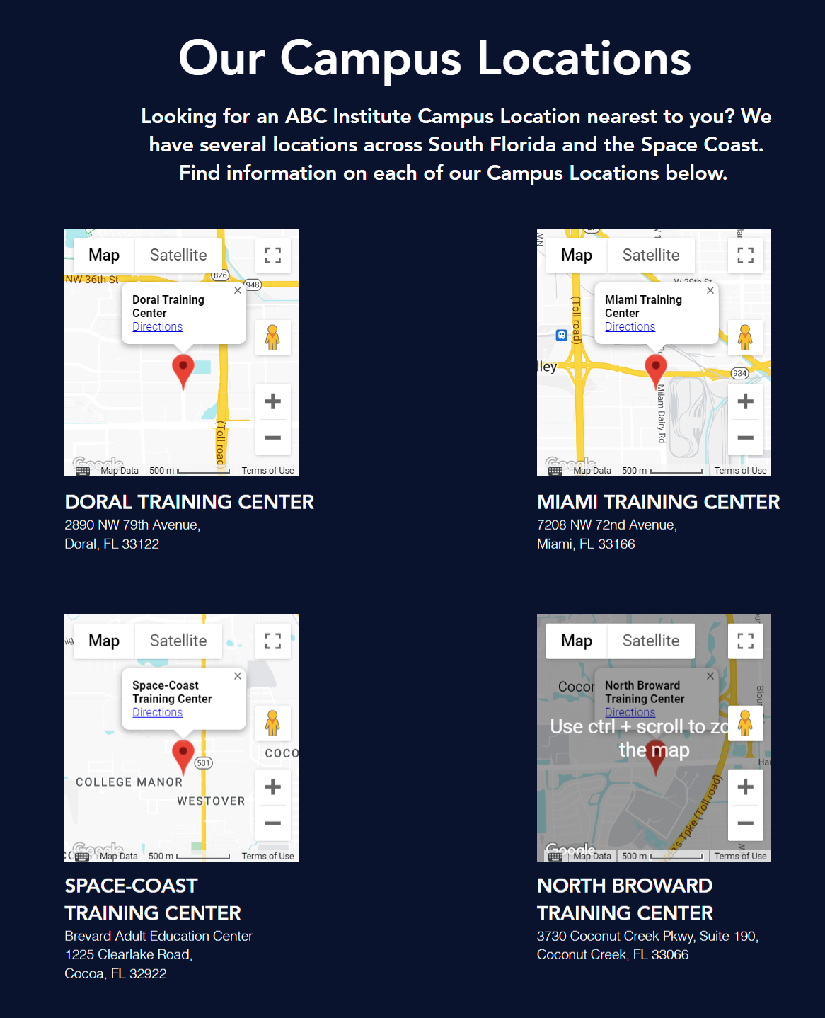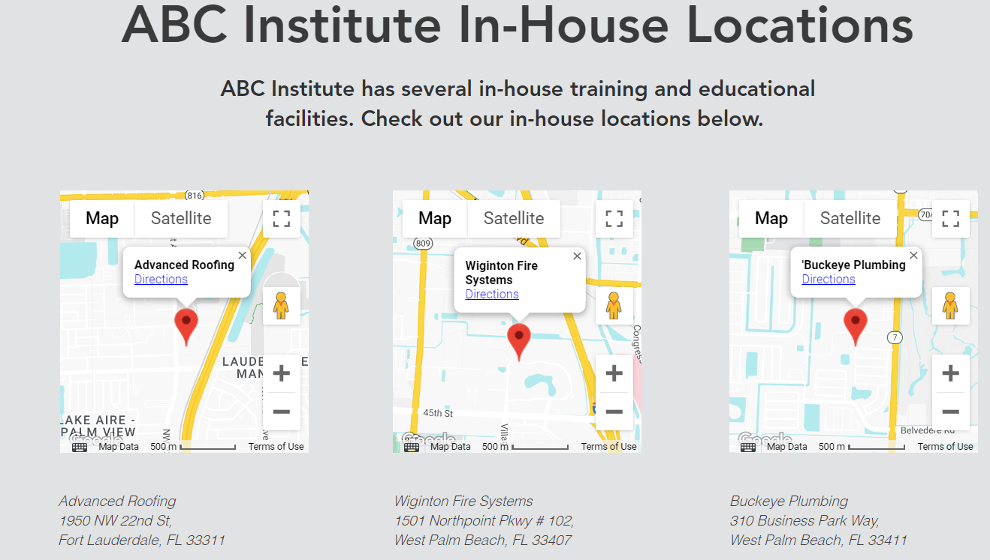

SEO Content Recommendation – Create Educational “Course Pages” for all classes taught. Including apprenticeship programs and safety training. (Similar characteristics as above)

Summary: Of SEO Audit for the WeTrain.org website
- The https://WeTrain.org website generates virtually no organic website traffic currently. In prior years the website provided 600 to 1,000 organic search visitors a month.
- Wetrain.org “on page” SEO issues need to be carefully analyzed and optimized to improve Google search results.
- The website recently lost over 79% of its inbound links to the WeTrain.org website.
- The word count on some web pages is low. We recommend that additional “ City landing pages” be created for each major city that are target markets for important keywords. Such as “Tampa office construction” or “Miami warehouse construction company”. These landing pages should have a word count of 850 words or more.
- The website has very few internal keyword “cross links”. These anchor text links are identified by Google as important keywords. Creating these internal links can boost search results for important keywords phrases.

Solution: The Search Engine Optimization Provider can…

- Identify and fix the all “on-page” SEO issues on all web pages. (Website login access required) One time charge of $1,500.
- Create a monthly inbound keyword anchor text linking program to the www.weTrain.org
- from our private network of US based blogs, and websites. $600 monthly fee.
- Create social media inbound links.
- Create website internal cross link using SEO keywords.
- Write 7 SEO optimized “City Pages” for each school location One time charge, 1,500+ words of content, $500 per page.
- Write 5 to 8 “Course Pages” One time charge, 1,500+ words of content, $500 per page.

Expectation for Results: Due to the large lead competitors have in current Google search results we would expect that it will take 6 to 9 months of ongoing SEO work to achieve first page results for important keywords.

Google My Business Listings (GMB)

Critical: For many important search keywords Google My Business Listings appear before organic search rankings. For a modest one-time fee, properly optimized GMB listings can rank high (Google 3 pack) vs. competitors and produce valuable website traffic and calls for 5 to 10 years or more. Cost: $500 per location. We recommend Google My Business Listings for each of the 4 primary location “City Pages”.

Characteristics of optimization of Google My Business Listings
- Maximize content for each GMB listing (approximately 60 fields of data and images).
- Create inbound links to GMB listings.
- Geo tagging of images.
- Create favorable 5-star review program.

